

NARULA INSTITUTE OF TECHNOLOGY
AGARPARA

DEPARTMENT NAME:

TITLE OF THE PROJECT:

SUBMITTED BY:

ROLL NUMBER:

GUIDED BY:

SESSION: 20__ - 20__

CERTIFICATE

This is to certify that
has completed the project titled

The project was carried out with sincerity, creativity, and dedication, demonstrating commendable understanding, technical competence, and commitment to quality work.

Project Guide Name:
Designation:
Signature:
Date:
Seal :

DECLARATION
We hereby declare that the project titled “Wearable Sensor Data Analytics for Health Monitoring” is an original work developed by us. This work has not been submitted, either in part or in full, to any other university or institution for the award of any degree or diploma. The work has been completed under the guidance of Ms. Suseta Datta.

Signatures:
Student Name:
Roll Number:
Signature:
Date:

ACKNOWLEDGMENT

We express our deep gratitude to our mentor, Ms. Suseta Datta, for her remarkable guidance, continuous support, and encouragement throughout this project. Her insightful suggestions and professional guidance were essential to the successful completion of this work.
We would also like to thank the Department of Computer Applications, Narula Institute of Technology, for providing the necessary resources, facilities, and academic environment to carry out this project successfully.

Abstract
Physiological stress detection using wearable sensor data has gained significant attention due to its applications in healthcare and human–computer interaction. However, many existing approaches rely on computationally heavy architectures that limit scalability and real-world deployment. This work presents a lightweight yet effective deep learning framework for multi-class affect recognition using the WESAD dataset. The proposed method integrates a one-dimensional Convolutional Neural Network (CNN) for local temporal feature extraction, followed by a Bidirectional Gated Recurrent Unit (BiGRU) to model long-range temporal dependencies, and a multi-head self-attention mechanism to emphasize salient temporal patterns.
Raw chest and wrist sensor signals are preprocessed through resampling, synchronization, and windowing into fixed-length segments of 10 seconds (320 time steps) with overlap. The model is trained and evaluated using a Leave-One-Subject-Out (LOSO) cross-validation strategy to ensure subject-independent generalization. To address the severe class imbalance inherent in the dataset, balanced batch sampling is employed and its impact is systematically compared against an unbalanced baseline.
Experimental results demonstrate that the proposed architecture achieves competitive performance while maintaining a significantly lower parameter count (~0.75M) compared to heavier CNN–LSTM-based models. Notably, balanced training improves minority-class recognition, particularly for stress-related states, without compromising overall performance. These findings highlight the effectiveness of lightweight hybrid architectures for physiological time-series classification and indicate strong potential for deployment in resource-constrained and real-time settings.

Chapter 1: Introduction

1.1 Background
Wearable sensor technology has enabled continuous and objective monitoring of physiological signals, facilitated the development of automated stress and affected recognition systems. Physiological signals such as electrocardiogram (ECG), electrodermal activity (EDA), respiration, temperature, and accelerometer data reflect changes in the autonomic nervous system and are widely used to infer emotional and mental states. The WESAD dataset provides multimodal chest and wrist sensor recordings collected under controlled affective conditions, making it a standard benchmark for stress detection research. Recent deep learning approaches have shown strong performance on such data; however, many rely on computationally intensive architectures that limit scalability and real-time deployment.

1.2 Problem Statement
Physiological affect recognition presents challenges due to strong inter-subject variability, temporal complexity of signals, and severe class imbalance in available datasets. Models trained on such data often fail to generalize to unseen subjects and exhibit poor recognition of minority classes. Additionally, many existing solutions prioritize accuracy through complex architectures, increasing computational cost and memory requirements. There is a need for a lightweight yet effective model that can capture temporal dependencies, generalize across subjects, and mitigate class imbalance without sacrificing efficiency.

1.3 Importance of the Study
This study is important as it explores a computationally efficient hybrid deep learning architecture for multi-class affect recognition using wearable sensor data. By combining convolutional, recurrent, and attention-based components, the proposed model captures both local and long-term temporal patterns while maintaining a low parameter count. The use of subject-independent evaluation and balanced training strategies provides practical insights into improving minority-class recognition and real-world robustness, making the approach relevant for scalable and deployable stress monitoring systems.

1.4 Scope of the Work
The scope of this research is limited to multi-class affect recognition using chest and wrist physiological signals from the WESAD dataset. The study considers four affective states—baseline, stress, amusement, and meditation—and employs signal preprocessing, fixed-length windowing, and deep learning-based classification. A CNN–BiGRU–Attention architecture is evaluated using Leave-One-Subject-Out cross-validation, with performance assessed through accuracy, macro F1-score, per-class F1-scores, and confusion matrices. The work focuses on architectural efficiency and training strategies rather than handcrafted feature engineering or additional sensor modalities.

Chapter 2: Literature Survey

The use of wearable devices in healthcare has become a significant development, offering constant monitoring, early disease detection, better patient results, and personalized care. Current work covers topics such as device design, data processing, the use of Artificial Intelligence, and systems that protect privacy. The following section looks at key studies that help to upgrade wearable technology for healthcare uses.

Alattar and Mohsen [1] conducted “A Survey on Smart Wearable Devices for Healthcare Applications”, which provides a wide view of smart wearable devices used in healthcare, looking at power sources, wireless communication, uses, and how comfortable they are to wear. Their analysis shows that solar power and lithium-ion batteries are the best options for collecting and storing energy, highlighting their recharge cycles and long-term durability. The study also emphasizes low-power electronics that extend battery life, which is critical for continuous patient monitoring. On the connectivity side, Bluetooth Low Energy (BLE) is considered ideal for close-range personal health monitoring because of its low energy consumption, while Wi-Fi provides greater bandwidth and range, making it more suitable for IoT-based hospital or telemedicine environments. These devices can be worn on the hands, arms, inside clothing, or on skin patches, and their ergonomic design directly affects patient comfort and compliance. Although the study gives useful insights into choosing hardware and how to deploy these devices, it does not include in-depth clinical testing to confirm their efficiency.
Meanwhile, Alhassan, Hamza, and Barolli [2] introduced SHARP: Blockchain-Powered WSNs for Real-Time Student Health Monitoring and Personalized Learning. Their research proposes a wireless sensor network that uses blockchain technology for secure and tamper-proof data management in schools. Physiological data collected by wearable sensors are processed through a deep neural network (DNN), which enables high-accuracy classification of health states such as fatigue, stress, or illness. Reinforcement learning (RL) is then employed to deliver personalized health and learning suggestions, adapting over time as new data is gathered. The use of Proof-of-Authority (PoA) blockchain ensures that health data remains confidential while also being transparent and auditable. The system achieved a 94.2% F1-score in simulated classroom environments, along with improved energy efficiency due to optimized data transmission. Despite these technological strengths, the model’s dependence on simulations raises concerns about scalability in real-world schools where sensor reliability, latency, and student acceptance can vary significantly.
In addition to the existing researches, Vieira, Carvalho, Marinho, and Almeida [3] carried out a systematic review on continuous movement monitoring at home through wearable devices. Their analysis of 72 studies shows that most wearable devices rely on inertial measurement units (IMUs), accelerometers, and gyroscopes—technologies embedded in devices like smartwatches, fitness bands, or medical-grade monitors. These sensors capture fine-grained motion data, which can be processed to assess mobility impairments, tremors, or gait abnormalities in patients with chronic or neurological conditions. High patient participation (at least 70%) suggests the practicality of these technologies, while agreement with clinical assessments demonstrates their diagnostic relevance. However, only half of the studies involved controlled trials, and randomized designs were less than 6%, limiting clinical rigor. The review highlights the promise of continuous, home-based monitoring technologies but also emphasizes the urgent need for standardized algorithms and data collection methods to validate performance across patient populations.
The paper published by Dilip Kumar et al. [4] explored a data analytics approach for health monitoring using wearable sensors. Their framework combined wearable sensors that captured vital signs like blood pressure, pulse rate, and body temperature with analytics implemented in Proteus Professional software. The sensor nodes employed biomedical sensing modules such as piezoelectric transducers for pulse rate, thermistors for body temperature, and pressure-sensitive cuffs for blood pressure. The platform simulated circuit-level integration of these sensor nodes with data transmission modules, demonstrating a workflow from data acquisition to decision-making. Real-time analytics in this model allowed for anomaly detection—such as unusual spikes in heart rate or blood pressure—through thresholding and rule-based decision systems. This work shows the potential of embedding intelligent analytics directly into sensor platforms for proactive intervention. However, since the approach was only validated through simulations and not with real-world patient datasets, its scalability and reliability remain untested.
To further contribute in the field of wearable sensor data analytics for health monitoring, Hossain and Muhammad [5] investigated the integration of wearable IoT devices with predictive analytics for remote health monitoring. Their study highlights IoT architecture where wearable devices act as data producers, transmitting real-time physiological signals to cloud-based predictive models. These models apply machine learning algorithms to detect abnormal patterns, such as arrhythmias in ECG data or irregular glucose fluctuations in diabetes patients. Edge computing was also discussed as a method to reduce latency and improve response times, especially in critical scenarios. The researchers underline privacy-preserving techniques such as encryption and federated learning to secure sensitive data while keeping predictive capabilities intact. While results showed potential for preventing adverse events, the complexity of real-time data handling and interpretability of AI models remain as key challenges before wide-scale adoption.
Khan, Islam, Sarkar, Islam, Paul, and Bari [6] examined real-time predictive health monitoring using AI-driven wearable sensors. Their system integrates wearable sensors with advanced machine learning techniques to predict the onset of chronic diseases. The sensors continuously collect physiological data such as heart rate, oxygen saturation, and blood glucose, which is analyzed in real-time using predictive models. Specifically, supervised algorithms such as Random Forests and Support Vector Machines (SVMs) were compared against deep learning models like Convolutional Neural Networks (CNNs) and Long Short-Term Memory (LSTM) networks for temporal sequence prediction. By identifying anomalies early, the system achieved a 25% reduction in hospital admissions and a 30% improvement in treatment compliance. A key technological highlight of this study is the use of streaming data pipelines that handle continuous sensor input efficiently. However, although the research demonstrates strong benefits, validation across diverse populations and integration with existing healthcare IT infrastructure remain future priorities.
Mahabub, Jahan, Islam, and Das [7] presented a data-driven analysis on the impact of wearable technology on health monitoring. Their review evaluates consumer-level technologies such as fitness trackers, smartwatches, and medical-grade wearables, focusing on how embedded sensors (e.g., photoplethysmography for heart rate and galvanic skin response for stress monitoring) impact healthcare outcomes. From a technical perspective, the review highlights how photoplethysmography (PPG) sensors rely on optical LED–photodiode pairs for capturing volumetric changes in blood flow, while galvanic skin response (GSR) electrodes measure variations in skin conductivity linked to emotional or stress states. It also notes that future medical-grade devices may integrate multi-modal sensing—combining PPG, ECG, and SpO₂ sensors with cloud-based AI models—to provide more reliable diagnostics. The study also introduces forward-looking technologies such as blockchain-based data sharing and AI-driven intervention platforms, which could extend the role of wearables beyond monitoring into personalized treatment guidance. Despite proposing innovative use cases, the study is limited by its reliance on secondary data and absence of new experiments, leaving questions about how these emerging technologies would perform in practice.
Furthermore, Parasuraman, Keshavan, and Raj [8] reviewed wearable devices and data collection considerations for connected health. Their work underlines the technological challenges of managing the large-scale data generated by continuous sensing devices. Issues such as interoperability between platforms, standardized data formats, and real-time cloud integration are highlighted. The authors argue for the adoption of universal communication protocols like HL7 FHIR and secure APIs to ensure smooth data exchange between different wearable devices and healthcare providers. By emphasizing these technological needs, the review underscores that achieving true “connected health” requires not just better devices but also robust infrastructure for data harmonization and storage.
Ave [9] studied wearable device data analysis for health monitoring and early disease detection. The focus was on computational techniques such as time-series analysis, machine learning classification, and deep learning for extracting useful health insights. For example, recurrent neural networks (RNNs) and convolutional neural networks (CNNs) were applied to detect anomalies in continuous health data streams. While the study demonstrates that these approaches can provide early warnings of potential health issues, it also highlights challenges including noisy sensor data, inconsistent sampling rates across devices, and privacy concerns in handling sensitive medical information.
Finally, Min, Tu, Xu, Lukas, Shin, Yang, Solomon, Mukasa, and Gao [10] discussed skin-interfaced wearable sweat sensors for precision medicine. Their study focuses on innovative electrochemical sensing techniques, where sweat biomarkers such as glucose, lactate, and electrolytes can be continuously monitored through skin-mounted flexible electronics. They emphasize advances in microfluidics that allow controlled sweat collection over long durations, along with biocompatible materials that improve skin adhesion and comfort. These sensors enable non-invasive monitoring, reducing reliance on blood tests, and paving the way for personalized treatment plans. Despite these promising developments, the study points out challenges in ensuring strong correlation between sweat biomarkers and traditional blood biomarkers, as well as in achieving stable performance in variable environmental conditions.
Looking across these studies, several common themes appear. Research focused on hardware highlights the significance of energy-efficient power collection and reliable wireless connections (Alattar and Mohsen [1]). Blockchain and advanced network technologies demonstrate secure and adaptive monitoring capabilities (Alhassan et al. [2]). Data analytics and artificial intelligence approaches convey the potential of wearable devices for predicting health concerns and enabling preventive care (Dilip Kumar et al. [4]; Hossain and Muhammad [5]; Khan et al. [6]; Ave [9]). Reviews emphasize the need for standard protocols, interoperability, and large-scale connected health ecosystems (Vieira et al. [3]; Mahabub et al. [7]; Parasuraman et al. [8]). Novel sensing platforms, such as sweat-based biochemical analysis, further extend the possibilities of personalized medicine (Min et al. [10]). While many studies report on feasibility and accuracy, clinical validation, scalability, and ethical safeguards remain key challenges. Future research should aim to create solid datasets, run properly controlled tests, and design systems that balance technological innovation with patient-centric usability and privacy.

Several recent studies have explored deep learning architectures for physiological stress and affect recognition, particularly using the WESAD dataset and similar wearable sensor benchmarks. Early approaches predominantly relied on conventional machine learning methods with handcrafted features; however, the growing availability of raw time-series data has shifted focus toward end-to-end deep learning models. Among these, hybrid architectures combining Convolutional Neural Networks (CNNs) with Long Short-Term Memory (LSTM) networks have been widely adopted due to their ability to capture local temporal patterns and long-term dependencies in physiological signals. CNN–LSTM models have demonstrated strong performance in multi-class stress detection tasks, but at the cost of increased computational complexity and parameter count, making them less suitable for deployment on resource-constrained wearable or edge devices.

Chapter 3: Research Methodology

3.1 Research Method
This research follows an experimental, model-driven methodology aimed at designing, implementing, and evaluating an efficient deep learning framework for physiological affect recognition using wearable sensor data. The study is empirical in nature and relies on systematic experimentation using a publicly available benchmark dataset. The overall research workflow consists of data preprocessing, model design, subject-independent training, performance evaluation, and comparative analysis under different training conditions.
A Leave-One-Subject-Out (LOSO) cross-validation strategy is employed to assess the generalization capability of the proposed model across unseen individuals. This evaluation protocol closely reflects real-world deployment scenarios, where models must perform reliably on users not encountered during training. Additionally, the research explicitly investigates the effect of class imbalance on model performance by comparing baseline training with balanced batch sampling, thereby enabling a controlled analysis of training strategies without altering the underlying dataset distribution.

3.2 Method Used

Dataset and Preprocessing
The WESAD (Wearable Stress and Affect Detection) dataset is used in this study. It contains multimodal physiological recordings collected from chest-worn and wrist-worn sensors under four affective states: baseline, stress, amusement, and meditation. In this work, only chest and wrist sensor modalities are considered to maintain practical relevance for wearable-based applications.
Raw sensor signals are first synchronized and resampled to a common sampling frequency of 32 Hz to ensure temporal alignment across modalities. Derived features such as accelerometer magnitude are computed to reduce dimensionality while preserving motion-related information. The synchronized signals are then segmented into fixed-length overlapping windows of 10 seconds (320 time steps) with 50% overlap. Each window is assigned a label using majority voting, ensuring temporal consistency of affective states.
All windows are standardized using z-score normalization based on training subjects only, preventing information leakage into validation or test subjects. The final input tensor for each window has a shape of (T = 320, C = 8), where T represents time steps and C represents sensor channels.

Model Architecture
The proposed model adopts a hybrid deep learning architecture composed of four primary stages:
- CNN Front-End
A one-dimensional Convolutional Neural Network (CNN) is applied along the temporal dimension to extract local temporal patterns from multichannel physiological signals. Two convolutional layers with 64 filters and kernel size 3 are used, employing same padding to preserve temporal resolution. ReLU activation functions introduce non-linearity, and dropout is applied to reduce overfitting.
- Bidirectional GRU Encoder
The CNN output is fed into a two-layer Bidirectional Gated Recurrent Unit (BiGRU) with a hidden size of 128 per direction. The bidirectional structure enables the model to capture both past and future temporal dependencies within each window, which is crucial for modeling physiological signal dynamics. Compared to LSTM networks, GRUs offer reduced computational complexity while maintaining strong temporal modeling capability.
- Multi-Head Self-Attention
A multi-head self-attention mechanism is applied over the temporal dimension of the BiGRU outputs. The attention module allows the model to focus on salient time steps that contribute most strongly to affective state discrimination. Attention is computed using the BiGRU output as query, key, and value vectors, enabling contextual re-weighting of temporal features.
- Pooling and Classification
The attention-enhanced sequence representations are aggregated using mean pooling across time, resulting in a fixed-length embedding. This embedding is passed through a fully connected layer with ReLU activation and dropout, followed by a softmax output layer that produces class probabilities for the four affective states.
The total parameter count of the model is approximately 0.75 million, making it significantly lighter than typical CNN–LSTM architectures used in prior work.

3.3 Modules
The system is organized into the following functional modules:
- Data Preprocessing Module
Responsible for loading raw WESAD data, synchronizing multimodal signals, resampling, windowing, normalization, and saving preprocessed data for efficient reuse.
- Feature Extraction Module
Implements CNN-based temporal feature extraction and GRU-based sequence modeling to capture both short-term and long-term signal patterns.
- Attention Module
Applies multi-head self-attention to emphasize informative temporal segments and suppress irrelevant or noisy signal regions.
- Training and Optimization Module
Handles LOSO cross-validation, in-memory data loading for GPU efficiency, mixed-precision training, gradient clipping, early stopping, and learning rate scheduling.
- Evaluation and Analysis Module
Computes evaluation metrics, generates confusion matrices, per-class F1 scores, and comparative analyses between baseline and balanced training strategies.

3.4 Analysis
Performance is evaluated using multiple complementary metrics to ensure a comprehensive assessment. Overall classification accuracy and macro-averaged F1-score are used to measure general performance, while per-class F1-scores provide insight into class-specific behavior, particularly for minority classes such as stress and amusement. Confusion matrices are analyzed to identify misclassification patterns and class overlaps.
To study the impact of class imbalance, two training configurations are compared:
- Baseline training, where samples are drawn according to their natural distribution.
- Balanced batch sampling, where each mini-batch contains approximately equal representation from all classes.
This comparative analysis allows for direct assessment of how training strategies influence minority-class recognition without modifying the dataset through synthetic oversampling techniques.

3.5 Tools and Platforms
The research is implemented using the Python programming language, leveraging the PyTorch deep learning framework for model development and training. NumPy and SciPy are used for numerical operations and signal processing, while scikit-learn is employed for evaluation metrics and preprocessing utilities. Data visualization and exploratory analysis are performed using Matplotlib and Seaborn.
Experiments are conducted on a system equipped with an NVIDIA RTX 4060 GPU and sufficient system memory to enable in-memory data loading, significantly accelerating training under the LOSO protocol. The development environment includes Jupyter Notebook for experimentation and modular code execution, facilitating reproducibility and iterative model refinement

Chapter 4: Implementation, Results, and Analysis

4.1 Experiment
The experimental setup is designed to evaluate the effectiveness, efficiency, and generalization capability of the proposed CNN–BiGRU–Attention model for multi-class affect recognition using physiological time-series data. Experiments are conducted on the WESAD dataset using chest and wrist sensor signals, with four affective states considered: baseline, stress, amusement, and meditation.
A Leave-One-Subject-Out (LOSO) cross-validation protocol is adopted, where data from one subject is held out for testing while the model is trained on the remaining subjects. This process is repeated for all subjects, and results are aggregated to obtain overall performance metrics. This evaluation strategy ensures that the model is tested on completely unseen subjects, providing a realistic measure of generalization performance.
Two experimental configurations are evaluated:
- Baseline training, where samples are drawn according to their natural class distribution.
- Balanced batch training, where each training mini-batch is constructed to contain approximately equal representation from all classes, addressing class imbalance without synthetic data generation.

4.2 Workflow
The complete implementation workflow of the system is illustrated through the following stages:
- Data Acquisition and Preprocessing
Raw physiological signals are loaded from the WESAD dataset, synchronized across modalities, resampled to a common frequency of 32 Hz, and segmented into overlapping 10-second windows. Labels are assigned using majority voting within each window, and the resulting data is standardized based on training subjects only.
- Model Initialization
The CNN–BiGRU–Attention model is initialized with predefined architectural parameters, including convolutional filters, GRU hidden size, attention heads, and dropout rates. Model weights are initialized using standard initialization techniques to ensure stable training.
- Training Phase
Training is performed using in-memory data loading to maximize GPU utilization. Mixed-precision training is enabled to improve computational efficiency. Early stopping and learning rate scheduling are applied to prevent overfitting and stabilize convergence.
- Evaluation Phase
After training each LOSO fold, the best-performing model checkpoint is loaded and evaluated on the held-out subject. Predictions are collected and used to compute performance metrics.
- Result Aggregation and Visualization
Results from all folds are aggregated to generate overall metrics, per-subject performance summaries, per-class F1-scores, and confusion matrices. Comparative analysis between baseline and balanced training configurations is performed.

4.3 Results

Overall Performance
The proposed model achieves consistent performance across subjects under the LOSO evaluation protocol. In the baseline configuration, the model attains an average classification accuracy of approximately 60%, reflecting the difficulty of subject-independent physiological affect recognition. The macro-averaged F1-score further highlights the impact of class imbalance, with strong performance on the majority class and reduced performance on minority classes.
When balanced batch sampling is applied during training, improvements are observed in macro-averaged F1-score, particularly for underrepresented classes such as stress and amusement. While overall accuracy shows marginal variation, balanced training leads to a more equitable distribution of predictive performance across classes.

Per-Class Analysis
Per-class F1-score analysis reveals that:
- The baseline class consistently achieves high F1-scores due to its dominance in the dataset.
- The stress class shows noticeable improvement under balanced training, indicating better sensitivity to stress-related physiological patterns.
- The amusement and meditation classes, which are severely underrepresented, benefit from balanced sampling, although their absolute performance remains constrained by limited data availability.
Confusion matrix analysis indicates that misclassifications frequently occur between physiologically similar states, such as baseline and meditation, highlighting the inherent overlap in affective physiological responses.

4.4 Outputs and Visualizations
The implementation produces several outputs that support quantitative and qualitative analysis:
- Class distribution plots illustrating dataset imbalance
- Training and validation loss curves for convergence analysis
- Per-subject accuracy and macro-F1 bar charts
- Normalized confusion matrices showing class-wise prediction behaviour
- Per-class F1-score plots for baseline and balanced training comparisons
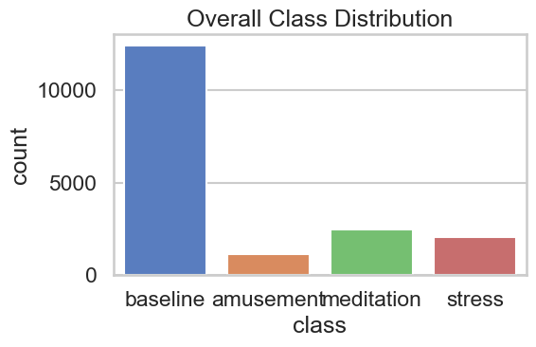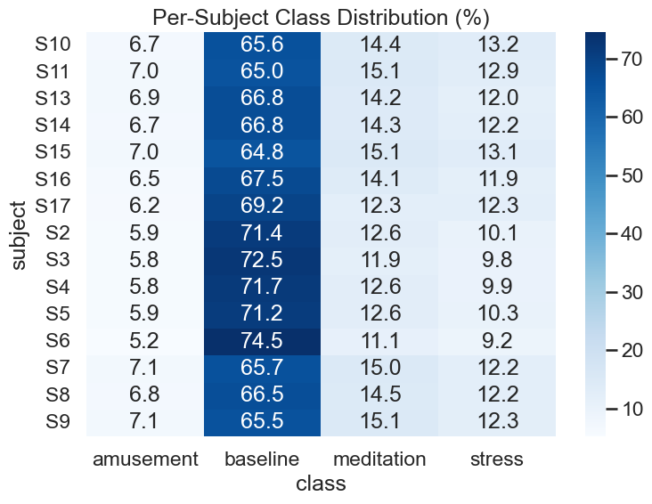

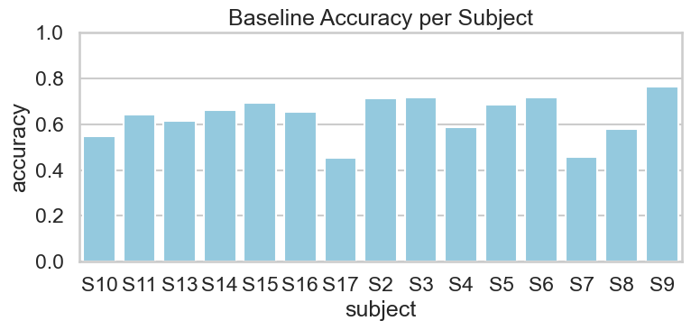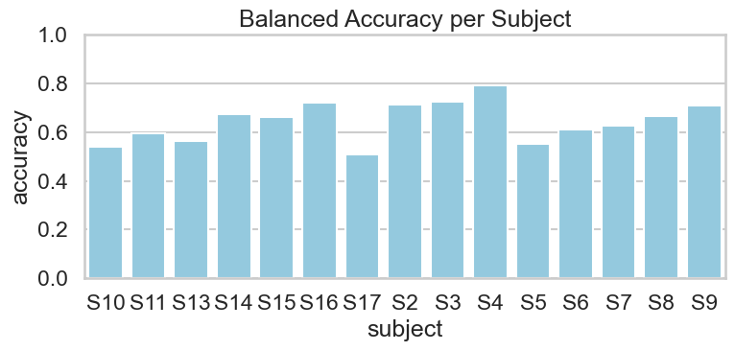
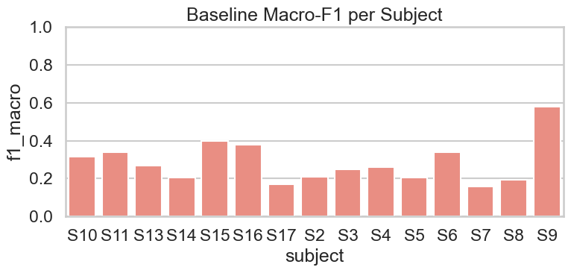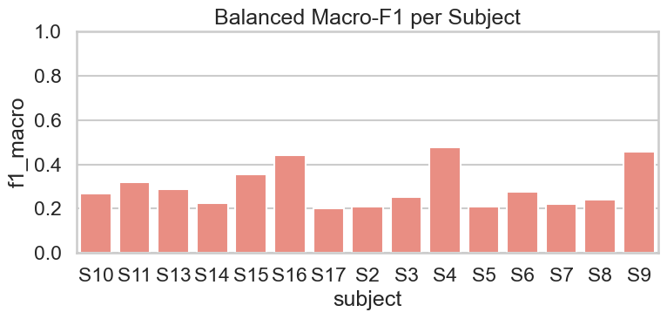
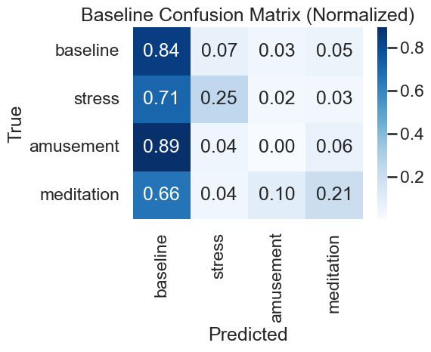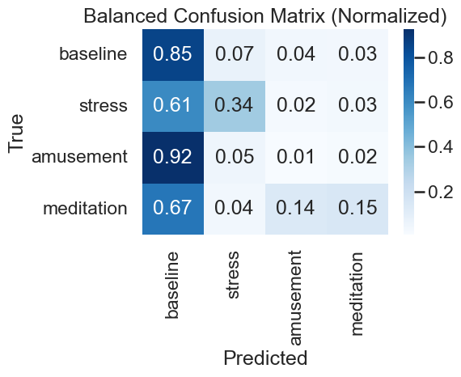
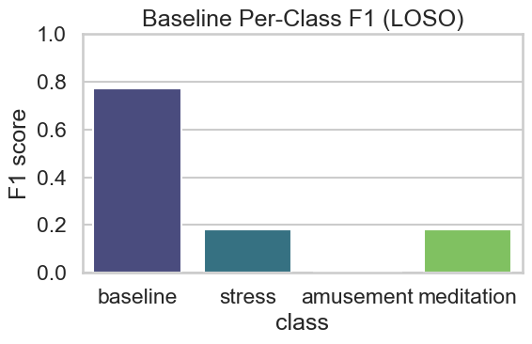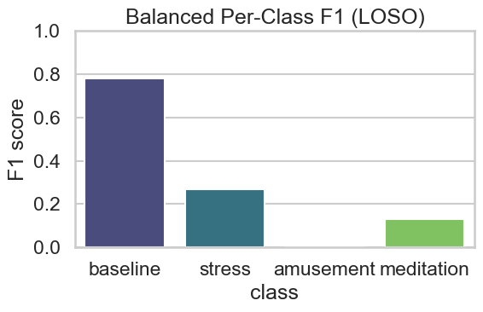

4.5 Experimental Observations (Survey-Equivalent Analysis)
Although this study does not involve human surveys, experimental observations serve an equivalent role in evaluating system effectiveness. Key observations include:
- Lightweight architectures can achieve competitive performance without excessive computational cost.
- Subject-independent evaluation significantly reduces apparent performance compared to subject-dependent splits, emphasizing the importance of realistic evaluation protocols.
- Addressing class imbalance through balanced batch sampling improves minority-class recognition more effectively than relying solely on weighted loss functions.
- Attention mechanisms contribute to improved temporal focus, enhancing robustness against noisy or less informative signal segments.

Chapter 5: Findings and Discussion

5.1 Findings
The experimental results demonstrate that the proposed CNN–BiGRU–Attention architecture is capable of learning discriminative temporal patterns from multimodal physiological signals while maintaining a relatively low computational footprint. Under the Leave-One-Subject-Out evaluation protocol, the model achieves stable performance across subjects, indicating effective subject-independent generalization. Although overall accuracy is moderate due to the inherent difficulty of the task, the macro-averaged F1-score highlights the model’s balanced predictive capability when appropriate training strategies are applied.
A key finding of this study is the impact of class imbalance on affect recognition performance. Baseline training exhibits strong performance on the majority class but underperforms on minority classes such as stress and amusement. The introduction of balanced batch sampling leads to consistent improvements in minority-class F1-scores, particularly for stress detection, without significantly increasing model complexity. This confirms that training strategy plays a crucial role in improving robustness on imbalanced physiological datasets.

5.2 Analysis
The performance trends observed in this study can be attributed to the architectural design and evaluation methodology. The CNN front-end effectively captures short-term temporal variations in physiological signals, while the Bidirectional GRU layers model long-range dependencies in both forward and backward temporal directions. The inclusion of a multi-head self-attention mechanism enables the model to focus on salient temporal segments within each window, enhancing discriminative capability without introducing excessive parameters.
Compared to CNN–LSTM-based architectures commonly reported in the literature, the proposed model achieves comparable performance with significantly fewer parameters, demonstrating improved efficiency. The use of LOSO cross-validation provides a realistic assessment of generalization, revealing performance degradation that is often masked in subject-dependent evaluations. Balanced batch sampling further addresses dataset bias, leading to more equitable performance across affective states. However, confusion matrix analysis indicates persistent overlap between physiologically similar classes, suggesting that some affective states remain challenging to distinguish based solely on the selected sensor modalities.

5.3 Limitations
Despite promising results, this study has several limitations. First, the WESAD dataset exhibits severe class imbalance, and although balanced batch sampling improves minority-class performance, absolute recognition rates for underrepresented classes remain limited. Second, the study focuses only on chest and wrist sensor modalities, excluding additional contextual or behavioural signals that could enhance affect discrimination. Third, fixed-length windowing may not optimally capture variable-duration affective responses. Finally, while the proposed model is lightweight compared to heavier architectures, real-time deployment and energy consumption were not explicitly evaluated on embedded or wearable hardware platforms.

Chapter 6: Conclusion

6.1 Summary
This research presented a lightweight deep learning framework for multi-class affect recognition using physiological time-series data from wearable sensors. A hybrid CNN–BiGRU–Attention architecture was designed to effectively capture local temporal patterns, long-range dependencies, and salient temporal segments while maintaining a low parameter count. The WESAD dataset was pre-processed through signal synchronization, resampling, and fixed-length windowing, and the model was evaluated using a Leave-One-Subject-Out cross-validation protocol to ensure subject-independent generalization.
Experimental results demonstrated that the proposed model achieves stable and competitive performance despite the inherent challenges of inter-subject variability and severe class imbalance. The use of balanced batch sampling improved minority-class recognition, particularly for stress-related states, without increasing model complexity. Overall, the findings confirm that lightweight hybrid architectures can provide an effective balance between performance and computational efficiency for physiological affect recognition tasks.

6.2 Recommendations
Based on the outcomes of this study, several recommendations can be made. First, lightweight recurrent architectures such as GRUs, when combined with attention mechanisms, should be preferred over heavier LSTM-based models for wearable and edge-based applications. Second, subject-independent evaluation protocols like LOSO should be adopted as a standard practice to ensure realistic performance assessment. Third, addressing class imbalance at the training stage through balanced sampling strategies is recommended over relying solely on weighted loss functions, as it leads to more equitable class-wise performance.
For practical deployment, it is recommended to prioritize models that balance accuracy with efficiency, especially in real-time or resource-constrained environments such as wearable devices and mobile health systems.

6.3 Future Scope
Future work can extend this research in several directions. Additional sensor modalities, such as contextual or behavioural data, could be integrated to improve discrimination between physiologically similar affective states. Adaptive or variable-length windowing strategies may further enhance temporal modelling of affective responses. Real-time inference and energy consumption analysis on embedded hardware platforms would provide deeper insight into deployment feasibility. Finally, advanced techniques such as domain adaptation or personalized fine-tuning could be explored to further improve subject-independent performance while preserving model efficiency.

References

[1] A. E. Alattar and S. Mohsen, “A Survey on Smart Wearable Devices for Healthcare Applications,” Wireless Personal Communications, vol. 132, pp. 775–783, 2023. doi:10.1007/s11277-023-10639-2.

[2] A. M. Alhassan, R. Hamza, and L. Barolli, “SHARP: Blockchain-Powered WSNs for Real-Time Student Health Monitoring and Personalized Learning,” Sensors, vol. 23, no. 24, pp. 1–20, 2023. doi:10.3390/s23249623.

[3] M. A. S. Vieira, J. F. Carvalho, L. B. Marinho, and A. A. de Almeida, “Continuous Movement Monitoring at Home Through Wearable Devices: A Systematic Review,” Sensors, vol. 25, no. 16, pp. 4889–4908, 2025. doi:10.3390/s25164889.

[4] S. Dilip Kumar, P. Manju, R. Nagalakshmi, R. M. Nandhini, B. Sangavi, and S. Agash, “Data Analytics Approach for Health Monitoring Using Wearable Sensors,” IT in Industry, vol. 9, no. 2, pp. 1062–1068, Apr. 2021.

[5] M. S. Hossain and G. Muhammad, “Integration of Wearable IoT Devices with Predictive Analytics for Remote Health Monitoring,” IEEE Internet of Things Journal, vol. 7, no. 7, pp. 5818–5825, Jul. 2020. doi:10.1109/JIOT.2019.2952337.

[6] A. J. M. O. R. Khan, S. A. M. Islam, A. Sarkar, T. Islam, R. Paul, and M. S. Bari, “Real-Time Predictive Health Monitoring Using AI-Driven Wearable Sensors: Enhancing Early Detection and Personalized Interventions in Chronic Disease Management,” International Journal of Advanced Computer Science and Applications (IJACSA), vol. 14, no. 9, pp. 123–132, 2023. doi:10.14569/IJACSA.2023.0140915.

[7] S. Mahabub, I. Jahan, M. N. Islam, and B. C. Das, “The Impact of Wearable Technology on Health Monitoring: A Data-Driven Analysis with Real-World Case Studies and Innovations,” Journal of Electrical Systems, vol. 20, no. 11s, pp. 172–183, 2024.

[8] R. Parasuraman, H. R. Keshavan, and S. M. P. Raj, “Review of Wearable Devices and Data Collection Considerations for Connected Health,” BioMed Research International, vol. 2021, Article ID 4030249, pp. 1–15, Jan. 2021. doi:10.1155/2021/4030249.

[9] J. Ave, “Wearable Device Data Analysis for Health Monitoring and Early Disease Detection,” International Journal of Artificial Intelligence and Machine Learning in Engineering, vol. 8, no. 2, pp. 116–122, Feb. 2008.

[10] J. Min, J. Tu, C. Xu, H. Lukas, S. Shin, Y. Yang, S. A. Solomon, D. Mukasa, and W. Gao, “Skin-Interfaced Wearable Sweat Sensors for Precision Medicine,” Chemical Reviews, vol. 123, no. 8, pp. 5049–5138, Apr. 2023. doi: 10.1021/acs.chemrev.2c00823.

